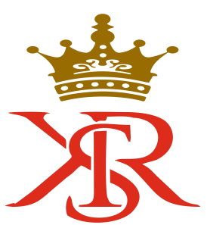

MANAGEMENT SYSTEM POLICY

KSR CERTIFICATION LLP(KSR) is KSR committed to offer Management System Certification and Training Services to the highest standard to all organizations without any discrimination, by delivering competent, consistent, impartial and value-added conformity assessments.

We wish to achieve our aims as a major international accredited certification body and recognize that effective management of our customers, our staff, our certification / Training process and our business results makes good business sense.

We want to achieve this by: -

Offering Certification and Training services in accordance with ISO 17021-1:2015 that is fair, impartial and objective to all who wish to avail themselves of our service,

Providing our customers with a professional service that is perceived to add value to their business and satisfy their expectations,

Practicing sound certification and Training principles through competent staff.

Developing an open exchange of information with organizations and the public on the certification and Training services that we offer,

Practicing sound business principles to manage the certification &Training body and give a return on our shareholder’s investment,

Communicating this policy to our staff, customers and interested parties.

Continual improvement in building capacity for meeting changing needs of certifications.

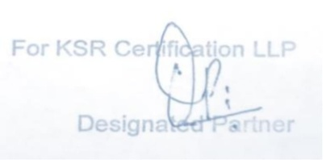
Managing Director {Mr. SHRI NARAVEDASHWAR DIXIT}

KSR CERTIFICATION LLP

